***mICROsOFT* sQL sERVER**

PROJECT FILE

BHARAT SINGH RAJPUT

ID: 717042

***BCA iiI SEMESTER***

NATIONAL POST GRADUATE COLLEGE,

LUCKNOW



SUBMITTED TO:

RESPECTED AMIT SIR

Q1. Consider the following database:

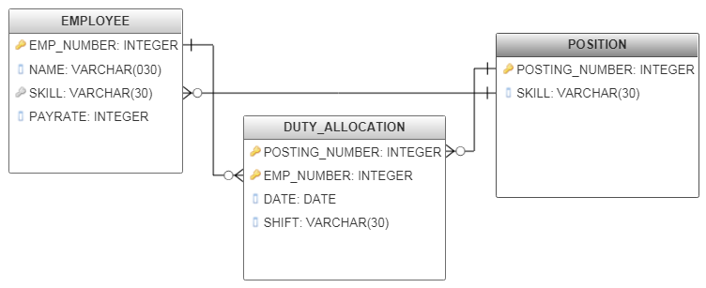

Creating tables:

CREATE TABLE POSITION (

POSTING_NUMBER INT PRIMARY KEY,

SKILL VARCHAR(30)

);

CREATE TABLE EMPLOYEE (

EMP_NUMBER INT PRIMARY KEY,

NAME VARCHAR(30),

SKILL VARCHAR(30),

PAYRATE INT

);

CREATE TABLE DUTY_ALLOCATION (

POSTING_NUMBER INT PRIMARY KEY,

EMP_NUMBER INT PRIMARY KEY,

DATE DATETIME,

SHIFT VARCHAR(20)

);

Inserting data into tables:

-- Position table

INSERT INTO POSITION VALUES(10011, 'PROGRAMMING')

INSERT INTO POSITION VALUES(10021, 'DATA ANALYSIS')

INSERT INTO POSITION VALUES(10031, 'GRAPHIC DESIGN')

INSERT INTO POSITION VALUES(10041, 'PROGRAMMING')

INSERT INTO POSITION VALUES(10051, 'DATA ANALYSIS')

INSERT INTO POSITION VALUES(10061, 'PROGRAMMING')

INSERT INTO POSITION VALUES(10071, 'DATABASE MANAGEMENT')

INSERT INTO POSITION VALUES(10081, 'SOFTWARE TESTING')

INSERT INTO POSITION VALUES(10091, 'SOFTWARE TESTING')

INSERT INTO POSITION VALUES(10101, 'HARDWARE DESIGN')

-- Employee Table

INSERT INTO EMPLOYEE VALUES(100, 'RAJESH KUMER', 'WEB DESIGNING', 1000)

INSERT INTO EMPLOYEE VALUES(102, 'KAPIL MATHUR', 'DATA ANALYSIS', 2000)

INSERT INTO EMPLOYEE VALUES(103, 'SATVIK MISHRA', 'DATA ANALYSIS', 1500)

INSERT INTO EMPLOYEE VALUES(104, 'SARVESH PRAJAPATI', 'PROGRAMMING', 3000)

INSERT INTO EMPLOYEE VALUES(105, 'CHIRAG SINGH', 'PROGRAMMING', 6000)

INSERT INTO EMPLOYEE VALUES(106, 'VIMLESH YADAV', 'SOFTWARE TESTING', 4000)

INSERT INTO EMPLOYEE VALUES(107, 'SALONI SINGH', 'WEB DESIGNING', 5800)

INSERT INTO EMPLOYEE VALUES(108, 'MAYA SINGH', 'DATABASE MANAGEMENT', 1200)

INSERT INTO EMPLOYEE VALUES(109, 'MITHILESH KUMAR', 'DATA ANALYSIS', 1700)

INSERT INTO EMPLOYEE VALUES(110, 'SWARNIMA GUPTA', 'BACKEND DEVELOPMENT', 1600)

INSERT INTO EMPLOYEE VALUES(111, 'RAVI SHANKAR KUMAR', 'DATABASE MANAGEMENT', 2600)

INSERT INTO EMPLOYEE VALUES(112, 'ABHAY SINGH', 'HARDWARE DESIGN', 3300)

INSERT INTO EMPLOYEE VALUES(113, 'AMIT KUMAR DUBEY', 'HARDWARE DESIGN', 3300)

INSERT INTO EMPLOYEE VALUES(114, 'ARYAN SRIVASTAVA', 'PROGRAMMING', 5400)

INSERT INTO EMPLOYEE VALUES(115, 'GAJENDRA RAJPUT', 'GRAPHIC DESIGN', 4300)

INSERT INTO EMPLOYEE VALUES(116, 'XYZ', 'WEB DESIGNING', 3400)

INSERT INTO EMPLOYEE VALUES(123461, 'SHIKHAR THAKUR', 'PROGRAMMING', 3700)

-- Duty Allocation Table

INSERT INTO DUTY_ALLOCATION VALUES(10011, 100, '1986-04-01', 'MORNING')

INSERT INTO DUTY_ALLOCATION VALUES(10011, 123461, '1986-04-01', 'EVENING')

INSERT INTO DUTY_ALLOCATION VALUES(10021, 101, '1986-05-01', 'EVENING')

INSERT INTO DUTY_ALLOCATION VALUES(10031, 102, '1986-06-01', 'AFTERNOON')

INSERT INTO DUTY_ALLOCATION VALUES(10041, 103, '1986-07-01', 'NIGHT')

INSERT INTO DUTY_ALLOCATION VALUES(10051, 104, '1986-08-01', 'MORNING')

INSERT INTO DUTY_ALLOCATION VALUES(10061, 105, '1986-09-01', 'MORNING')

INSERT INTO DUTY_ALLOCATION VALUES(10071, 106, '1986-10-01', 'AFTERNOON')

INSERT INTO DUTY_ALLOCATION VALUES(10081, 107, '1986-11-01', 'NIGHT')

INSERT INTO DUTY_ALLOCATION VALUES(10091, 108, '1986-12-01', 'EVENING')

INSERT INTO DUTY_ALLOCATION VALUES(10091, 109, '1987-01-01', 'MORNING')

INSERT INTO DUTY_ALLOCATION VALUES(10101, 110, '1987-02-01', 'NIGHT')

INSERT INTO DUTY_ALLOCATION VALUES(10021, 111, '1987-03-01', 'EVENING')

INSERT INTO DUTY_ALLOCATION VALUES(10021, 112, '1987-04-01', 'EVENING')

INSERT INTO DUTY_ALLOCATION VALUES(10051, 113, '1987-05-01', 'NIGHT')

INSERT INTO DUTY_ALLOCATION VALUES(10061, 114, '1987-06-01', 'MORNING')

INSERT INTO DUTY_ALLOCATION VALUES(10031, 115, '1987-07-01', 'AFTERNOON')

INSERT INTO DUTY_ALLOCATION VALUES(10031, 115, '1987-07-01', 'AFTERNOON')

INSERT INTO DUTY_ALLOCATION VALUES(10041, 116, '1987-08-01', 'EVENING')

Queries:

1. Get duty allocation details for employee number 123461 for the month of april 1986.

SELECT A.* FROM DUTY_ALLOCATION A INNER JOIN EMPLOYEE B

ON A.EMP_NUMBER = B.EMP_NUMBER

WHERE DATE = '1986-04-01' AND A.EMP_NUMBER = 123461

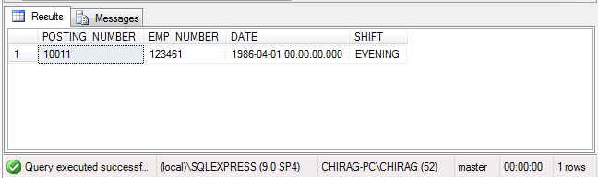

2. Find the shift details for employee ‘XYZ’.

SELECT A.* FROM DUTY_ALLOCATION A INNER JOIN EMPLOYEE B

ON A.EMP_NUMBER = B.EMP_NUMBER

WHERE NAME = 'XYZ'

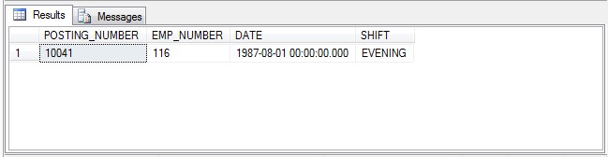

1. Get details of employees whose rate of pay is more than or equal to the rate of pay of employee ‘XYZ’.

SELECT * FROM EMPLOYEE

WHERE PAYRATE >= (SELECT PAYRATE FROM EMPLOYEE WHERE NAME = 'XYZ')

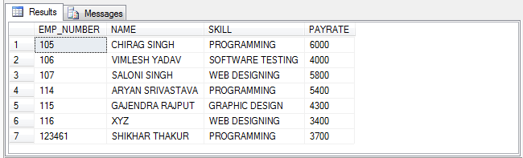

1. Compile all the pairs of posting number requiring the same skill.

SELECT A.POSTING_NUMBER, B.POSTING_NUMBER, A.SKILL

FROM POSITION A, POSITION B

WHERE A.SKILL = B.SKILL

AND A.POSTING_NUMBER <> B.POSTING_NUMBER

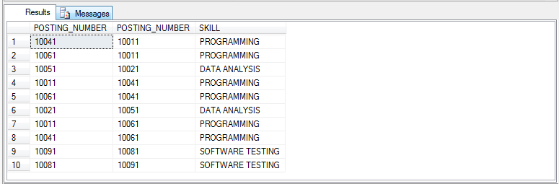

1. Find all the employees eligible to fill a position.

SELECT * FROM EMPLOYEE WHERE SKILL = ANY(SELECT SKILL FROM POSITION)

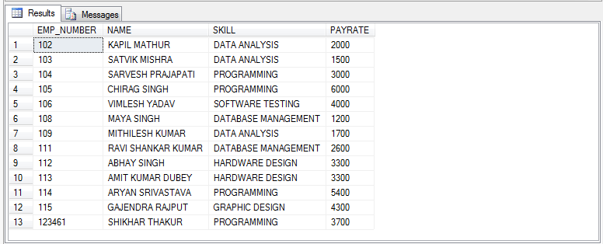

Q2. Consider the following database:

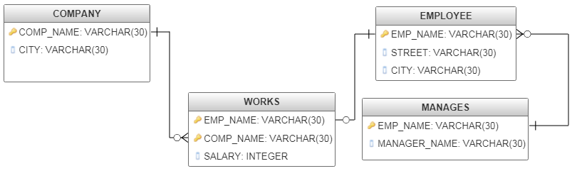

Creating tables:

CREATE TABLE EMPLOYEE (

EMP_NAME VARCHAR(30),

STREET VARCHAR(30),

CITY VARCHAR(30)

);

CREATE TABLE WORKS (

EMP_NAME VARCHAR(30),

COMP_NAME VARCHAR(30),

SALARY INT

);

CREATE TABLE COMPANY (

COMP_NAME VARCHAR(30) PRIMARY KEY,

CITY VARCHAR(30)

);

CREATE TABLE MANAGES (

EMP_NAME VARCHAR(30),

MANAGER_NAME VARCHAR(30)

);

Inserting data into tables:

-- Employee Table

INSERT INTO EMPLOYEE VALUES('HARI', 'VIKAS NAGAR', 'LUCKNOW')

INSERT INTO EMPLOYEE VALUES('SUBHASH', 'JUHU', 'MUMBAI')

INSERT INTO EMPLOYEE VALUES('AJIT', 'GOREGAON', 'DELHI')

INSERT INTO EMPLOYEE VALUES('CHIRAG', 'KHURRAM NAGAR', 'LUCKNOW')

INSERT INTO EMPLOYEE VALUES('VISHAL', 'CHANDNI CHAUK', 'DELHI')

INSERT INTO EMPLOYEE VALUES('SURESH', 'HAZRATGANJ', 'LUCKNOW')

INSERT INTO EMPLOYEE VALUES('RAJESH', 'GOREGAON', 'DELHI')

INSERT INTO EMPLOYEE VALUES('KIRAN', 'RAJENDRA NAGAR', 'KANPUR')

INSERT INTO EMPLOYEE VALUES('KAPIL', 'LALBAGH', 'LUCKNOW')

INSERT INTO EMPLOYEE VALUES('RAM', 'TILAK NAGAR', 'DELHI')

-- Works Table

INSERT INTO WORKS VALUES('HARI', 'SBI', 20000)

INSERT INTO WORKS VALUES('SUBHASH', 'PNB', 35500)

INSERT INTO WORKS VALUES('AJIT', 'PNB', 45000)

INSERT INTO WORKS VALUES('CHIRAG', 'HDFC', 60000)

INSERT INTO WORKS VALUES('VISHAL', 'HDFC', 45000)

INSERT INTO WORKS VALUES('SURESH', 'SBI', 27000)

INSERT INTO WORKS VALUES('RAJESH', 'SBI', 25000)

INSERT INTO WORKS VALUES('KIRAN', 'UBI', 30000)

INSERT INTO WORKS VALUES('KAPIL', 'UBI', 40000)

INSERT INTO WORKS VALUES('RAM', 'ICICI', 30000)

-- Company Table

INSERT INTO COMPANY VALUES('SBI', 'LUCKNOW')

INSERT INTO COMPANY VALUES('UBI', 'DELHI')

INSERT INTO COMPANY VALUES('HDFC', 'MUMBAI')

INSERT INTO COMPANY VALUES('PNB', 'PUNE')

INSERT INTO COMPANY VALUES('ICICI', 'BHOPAL')

-- Manages Table

INSERT INTO MANAGES VALUES('HARI', 'MAYANK')

INSERT INTO MANAGES VALUES('SUBHASH', 'PRASHANT')

INSERT INTO MANAGES VALUES('AJIT', 'PRABHASH')

INSERT INTO MANAGES VALUES('CHIRAG', 'SHIVAM')

INSERT INTO MANAGES VALUES('VISHAL', 'PARAS')

INSERT INTO MANAGES VALUES('SURESH', 'PULKIT')

INSERT INTO MANAGES VALUES('RAJESH', 'PUSHP')

INSERT INTO MANAGES VALUES('KIRAN', 'MOHIT')

INSERT INTO MANAGES VALUES('KAPIL', 'SHALEEN')

INSERT INTO MANAGES VALUES('RAM', 'FAIZ')

Queries:

1. Find the name of all the employees who work for SBI.

SELECT A.EMP_NAME FROM EMPLOYEE A INNER JOIN WORKS B

ON A.EMP_NAME = B.EMP_NAME

WHERE B.COMP_NAME = 'SBI'

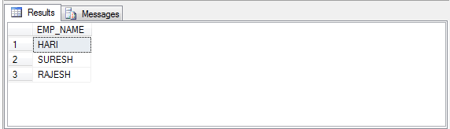

1. Find the names and cities of recidence of all the employees who work for SBI.

SELECT A.EMP_NAME, A.CITY FROM EMPLOYEE A INNER JOIN WORKS B

ON A.EMP_NAME = B.EMP_NAME

WHERE B.COMP_NAME = 'SBI'

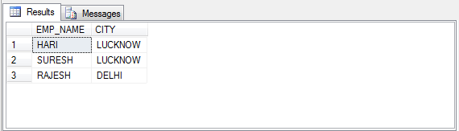

1. Find all the employees in the database who do not work for SBI.

SELECT A.* FROM EMPLOYEE A INNER JOIN WORKS B

ON A.EMP_NAME = B.EMP_NAME

WHERE B.COMP_NAME <> 'SBI'

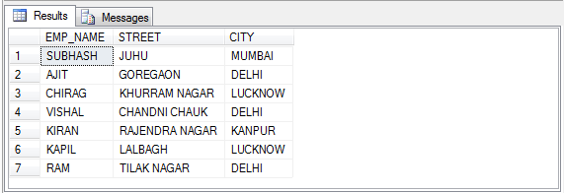

1. Modify the database so that Hari now lives in Pune.

UPDATE EMPLOYEE SET CITY = 'PUNE', STREET = 'XYZ'

WHERE EMP_NAME = 'HARI'

SELECT * FROM EMPLOYEE WHERE EMP_NAME = 'HARI'

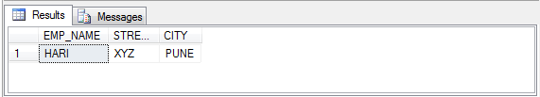

1. Delete all touples in works relation for employees of SBI

DELETE FROM WORKS WHERE COMP_NAME = 'SBI'